**BIOL 3295 Lab 8: Burton’s Pond duck population**

Lab report due: Thursday December 21, 12pm.

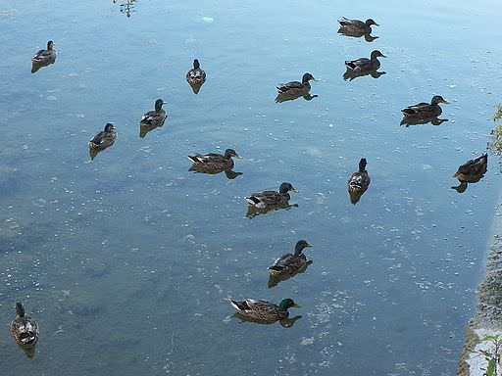

Your report should include:

1. The image analysis of Ducks_Example.jpg. Include only the final picture that shows the ducks counted. Write 1 sentence commenting on the accuracy of the image analysis method.
2. Your graph of the number of ducks counted for both Fall and Winter 2017, the intercepts and slopes of the regressions and information on whether the slopes and intercepts suggest a meaningful relationship (for both Fall and Winter 2017). The figures should have informative axis labels and a figure capture explaining all the symbols.

Part 1: Image analysis

Population counts can be made using imagine analysis software (i.e., ImageJ) if there is a good contrast between the objects being counted and the background. This may reduce human error or speed up the data analysis process, depending on the details of the population being counted (i.e. population size, sample size, number of photos, contrast, etc).

In ImageJ, Go to *File > Open >* and find the file Ducks_Example.jpg.

Once loaded, convert your image to 8-bit type (i.e. black and white) using *Image > Type > 8-bit*.

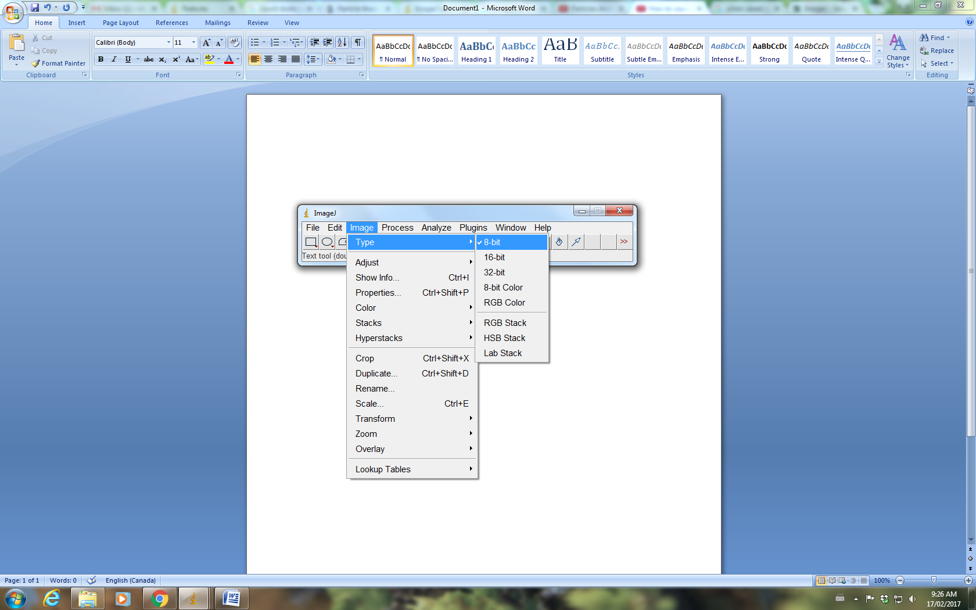

Adjust the threshold of your image for particle analysis using the slider bars under *Image > Adjust > Threshold.*

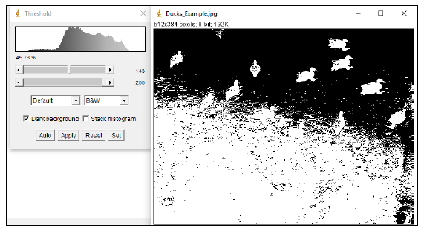

You want the ducks to be the main feature appearing in your binary image (see below).

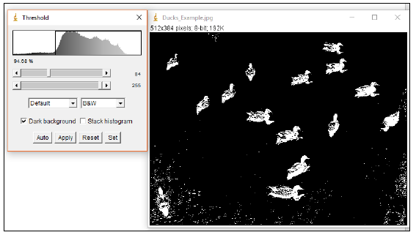

Depending on the photo used you may need to crop excess information out of the photo (not necessary for the example photo). Select the area you wish to crop by clicking and dragging your cursor across the screen using the *Rectangular* selection tool, or another selection tool of your choice. The resulting image will be a rectangle either way. Go to *Image > Crop* to apply the cropping.

Next, we will calculate a Euclidean distance map. This is an intensity weighted image were your objects are made an intensity of 0 and each pixel away from them is increased in intensity by 1. This is important for images that are not noiseless (i.e. including background objects such as greenery, buildings, etc). *Process > Binary > Distance Map* will give you a Euclidean distance map (see below).

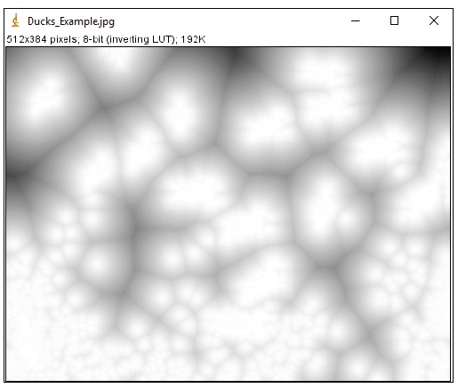

Once you have a distance map you and set a threshold value to select all cells that are a given number of pixels apart (i.e clumps of cells). *Image > Adjust > Threshold.* Adjust the values until only the ducks are visible, similar to the first threshold adjustment that you made (see below). 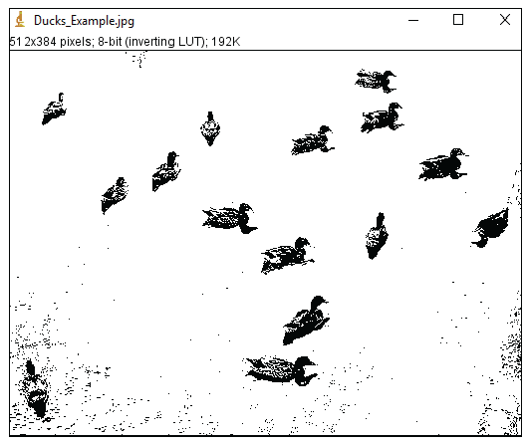

Once you have a binary image of the particles you wish to count, go to *Analyze > Analyze Particles.* Set *Pixel size* ~200 to infinity for the example photo (but this will depend on photo used). **You may need to do this step several** times until you find a value that works best – just ensure you do not close the original image during this process or you must start from the beginning again.

Set *Show* to *Outlines*,and make sure *Clear results* and *Summarize* are checked (see below).

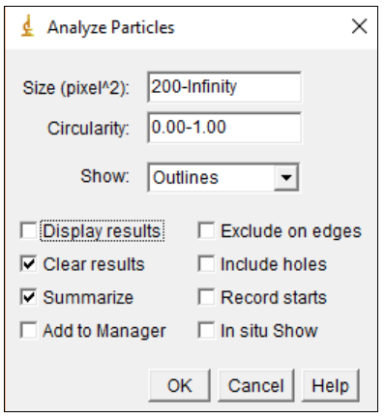

Click OK. A copy of the image is made, and all counted particles are shown as numbered outlines (see below). When you are happy with the results, **this is the image you should submit with your lab report.**

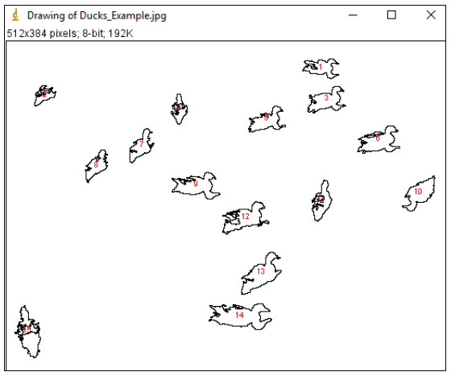

These numbers correspond to data for individual particles that are listed in the *Results* window if you check the *Display Results* option (which is unnecessary for us). Clear *Results* clears the *Results* window before a new run. Summarize gives a summary window with the name of the image, total counts and other information for the whole image (shown below). If you count multiple images, all counts remain listed in the *Summary* window, even if you clear the *Results* window, just do not close the *Summary* window.

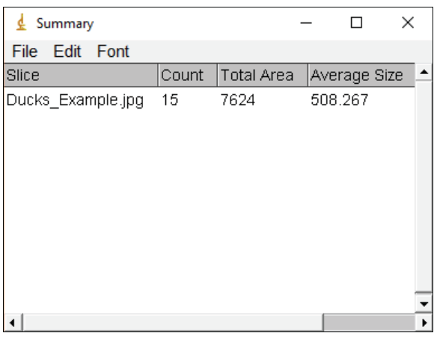

Part 2: Duck counts over time.

Run the file Lab8F2017.R. This file should run once you have correctly set the path to the data, and in fact, if both the data (.csv) and the R script are saved in the same directory if should run automatically. For the data collected in Winter 2017 make sure you know what the different coloured symbols correspond to and mention this in the figure caption.